**BALLYMAHON MUNICIPAL DISTRICT**

**Minutes of Meeting of Ballymahon Municipal District**

**held in Edgeworthstown Library and via MSTeams**

**on Thursday 23 May 2024 at 10:30am**

**­­­­­­­­­­­­­­­­­­­­­­­­__________________________________________________________________________**

**CATHAOIRLEACH**: Councillor Paul Ross

**MEMBERS PRESENT**: Councillors – Pat O’Toole, Mick Cahill, Gerard Farrell, Mark Casey and Colm Murray

**IN ATTENDANCE:**  Ms. Samantha Healy, Director of Service

Mr. Brian Mc Neela, A/Senior Executive Engineer

Mr. Darren Lennon, Technician

Ms. Claire McDermott, Administrative Office

**APOLOGIES:** None

**MEETINGS ADMINISTRATOR**: Ms. Claire McNabola

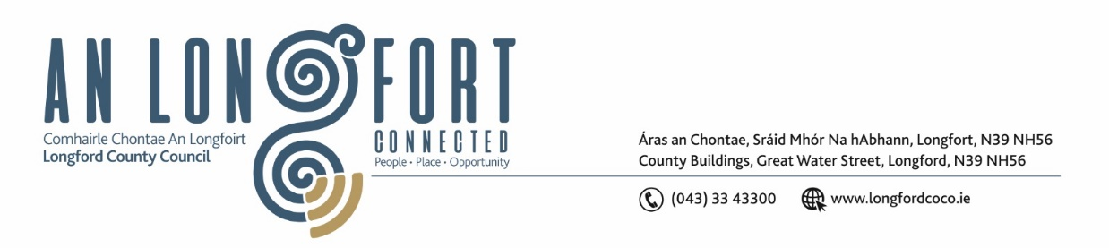**1.ADOPTION OF MINUTES**

On the proposal of Councillor Pat O’Toole seconded by Councillor Mick Cahill the Minutes of Committee Members of Ballymahon Municipal District Meeting held on the 28 March 2024, as circulated, were confirmed and adopted.

On the proposal of Councillor Mick Cahill seconded by Councillor Gerard Farrell the Minutes of Ballymahon Municipal District Meeting held on the 28 March 2024, as circulated, were confirmed and adopted.

**2. MATTERS ARISING FROM MINUTES**

None

**3. DECLARATION OF INTEREST BY MEMBERS**

Councillor Colm Murray declared he has an interest in the Community Grant Application for Ardagh Defibrillator Group.

**4. MANAGEMENT REPORT – as circulated**

The members noted the Management report,

**5. ARDAGH CLOCK TOWER**

John Lyons and Cathy Lynch from Ardagh Clock Tower Committee made a short presentation to the Members on both the current status of the Clock Tower and the challenges the committee faced and are faced with.

The committee thanked Longford County Council for their help and support in on the journey to securing title. They thanked the Heritage Council for awarding them €25kin grant aid towards the renovation works.

Director of Services Samantha Healy was delighted to inform the Members that the Legal team has advised Longford County Council that the legal aspect as regards title has now been resolved.

The committee sought the support of the Members of Ballymahon MD to fund the shortfall to carry out the works. The total cost of the works is as follows:

|  |  |
| --- | --- |
| Restoration Costs | €80k |
| Committee Funds | €25k |
| Heritage Grant | €25 |
| Shortfall | €30k |

The members agreed they would explore avenues internally for sources for funding and revert to the Committee following the Local Elections. It was agreed that Ardagh Clock Tower would remain as an agenda item for the July Meeting of Ballymahon MD.

The committee was informed that they have the fill support of both the Members of Ballymahon MD and that of the Executive of Longford County Council.

**6. COMMUNITY GRANTS**

On the proposal of Councillor Mark Casey, seconded by Councillor Mick Cahill it was unanimously agreed to give €1000.00 to Ardagh Defibrillator Group. The purpose of the funds is for maintenance, new batteries and training.

**7. NOTICE OF MOTIONS, SUBMITTED BY COUNCILLORS, AS LISTED HEREUNDER**

**The following Notice of Motion was proposed by Councillor Paul Ross and seconded by Councillor Pat O’Toole**

1. That Longford Co Council carry out an upgrade to the pedestrian crossing lights at Mercy Secondary School, Main St, Ballymahon

**Response: Con Diffley – Road Design**

Longford Co Co have reviewed lighting levels at St Matthews Church. The street lighting will be upgraded to ensure appropriate lighting levels are in place at the pedestrian crossing.

**The following Notice of Motion was proposed by Councillor Paul Ross and seconded by Councillor Mick Cahill**

1. That Longford Co Co Review the speed limit at the Moor Ardagh on the R393 and reduce to a 50KM limit at the Football pitch in the interest of public safety.

**Response: Con Diffley - Road Design**

Local Authorities have been recently requested to commence a review of speed limits. This review is to be carried out in accordance with a recent circular RS01 / 2024 and as of yet unpublished revised guidance on setting and managing speed limits.

Longford County Council will take the above Notice of Motion as a submission to be included in the forthcoming speed limit reviews.

**The following Notice of Motion was proposed by Councillor Paul Ross and seconded by Councillor Pat O’Toole**

1. That Longford Co Co introduce a solid white line on the R393 on the approach to Carrickboy from Ballycloughan

**Response: Con Diffley – Road Design**

The 1.4km section of R393 between Ballycloghan and Carrickboy which currently has a broken centre line road marking, is generally straight and has appropriate forward sight distance necessary for safe overtaking manoeuvres.

As such it is not recommended that a solid centre line is provided between Ballycloghan and Carrickboy.

**The following Notice of Motion was proposed by Councillor Pat O’Toole and seconded by Councillor Gerard Farrell**

1. I call on Longford County Council to carry out a low-cost safety scheme at the junction of the  L1133 and the L1130 at Shrule Junction to improve the sight lines and in the interest of public safety

**Response: Con Diffley – Road Design**

The 1.4km section of R393 between Ballycloghan and Carrickboy which currently has a broken centre line road marking, is generally straight and has appropriate forward sight distance necessary for safe overtaking manoeuvres.

As such it is not recommended that a solid centre line is provided between Ballycloghan and Carrickboy.

**The following Notice of Motion was proposed by Councillor Pat O’Toole and seconded by Councillor Paul Ross**

1. I call on Longford County Council to assess the feasibility of putting a footpath in place from the Silver Birches Estate to Young Grattans GAA grounds at Dunbeggan Longford.

**Response: Brian Kelly – Active Travel**

The Active Travel previously submitted an unsuccessful funding application to the NTA in November 2022 for a footpath scheme to link from Silver Birches to Stonepark School.

A refreshed application for funding is currently being prepared and will be submitted by end of May 2024.

This project will be subject to agreement with landowner for setting back of field boundaries to facilitate path installation.

Cathaoirleach Councillor Paul Ross together with all of the Members wished each other luck in the upcoming Local Elections.

The members acknowledge the support and work of the Executive and the staff of Longford County Council and look forward to working with them all again post elections.

**Signed:_____________________**

**Claire McNabola**

**Meetings Administrator**

**Confirmed and adopted at Ballymahon Municipal District Meeting held on the 25 July 2024.**

**Signed: _______________**

**Cathaoirleach**